**1. Name of Service**

Custom CRISPR Validation Service

**2. Description:**

Performed a CRISPR experiment, but unsure whether you have the right cell clone for your research? Looking for a third party to confirm your CRISPR results for publication? **abm** is proud to offer a variety of CRISPR validation options – from sgRNA efficiency screening, genomic cleavage assay, analysis by Sanger sequencing or NGS, to protein-level validation – to provide thorough validation of your CRISPR results.

**3. Inquire Form:**

Name*

Institution/Company Email*

Choose a service:

- sgRNA Efficiency Screening

- Mismatch Cleavage Detection Service

- SpeedySeq Sequencing of Target Region

- SpeedySeq Sequencing of Target PCR Amplicon

-Protein CRISPR Validation Service

Total Number of samples

Additional Comments

**4. Image: (Have the image clickable and jump to the workflow section below)**

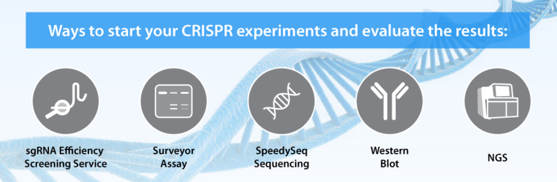

**5. Testimonial:**

Video: CRISPR Cas9 - Screening and Validation Strategies

"We are quite happy with the knockout cells that you made. This was a tricky knockout and hemizygous removal was much more prevalent than the double knockout, but you did it. In addition to your excellent genomic sequence characterization of both mutant LIF alleles, I have confirmed in our lab that the tumor cells have lost all mouse LIF production."

*Dr. Robert Jackman, Boston University, Mouse LIF CRISPR Knock Out C26 Tumor Cell Line Generation and Screening Service*

**6. Service Details**

**Core Services:**

|  |  |  |  |
| --- | --- | --- | --- |
| **SERVICE** | **UNIT** | **CAT. NO.** | **UNIT PRICE** |
| sgRNA Efficiency Screening Service  # List price includes screening up to a set of 4 sgRNAs with 1 set of primers.  Additional services:   * $95 per additional sgRNA tested (C531) * $99 per additional primer design & synthesis required (C532) | 1 Service | C526 | $950# |
| Mismatch Cleavage Detection Service (Surveyor/T7E1 Assay)  *Minimum sample requirement: 8 samples | 1 Sample | C527 | $250 |
| SpeedySeq Sequencing of Target Region  *PCR amplicon of target region is subcloned into a vector and 10 isolated colonies are sequenced to investigate the exact edited sequence*  *Sample is based on sequencing one target region, for sequencing multiple regions in the same sample, additional charges will apply. | 1 Sample | C528 | $385 |
| SpeedySeq Sequencing of PCR Amplicon  *PCR amplicon of target region is directly sequenced without subcloning to assess whether edits are present.*  *Sample is based on sequencing one target region, for sequencing multiple regions in the same sample, additional charges will apply. | 1 Sample | C529 | $75 |
| Validation Service by Western Blot (Up to 10 Clones) | 1 Service | C145 | $975 |
| CRISPR-Cas9 Amplicon-Seq | 1 Sample | IA00100 | $600 |
| Off-Target Analysis by Whole Genome Sequencing (Human, 30X coverage, 2x150bp PE)  *A minimum of two samples must be submitted, 1 Wildtype for control and 1 edited sample | 1 Sample | IW20900 | $1795 |

**Add-On Services:**

|  |  |  |  |
| --- | --- | --- | --- |
| **SERVICE** | **UNIT** | **CAT. NO.** | **UNIT PRICE** |
| gDNA Isolation from cell pellet | Per Cell Pellet | C530 | $50 |

**7. Additional Info**

**Service Selection Guide**

|  |  |  |  |
| --- | --- | --- | --- |
| **Service** | **Purpose** | **Materials to Submit** | **Deliverables** |
| sgRNA Efficiency Screening Service | Validate sgRNA designs *in vitro* prior to performing CRISPR experiments | 1. Cell pellet or isolated gDNA from target cells. Alternatively, **abm** can provide 293T gDNA for free 2. sgRNA sequence information | Report with Cleavage assay gel image showing the cleavage efficiency of the different sgRNA designs |
| Mismatch Cleavage Detection Service (Surveyor/T7E1 Assay) | Upon infection, determine if the polyclonal pool of cells contains edits | 1. gDNA or cell pellet of CRISPR-edited samples 2. gDNA or cell pellet from Wildtype cell sample | Cleavage detection assay gel image |
| SpeedySeq Sequencing of Target Region | Provides detailed sequence information of the CRISPR target region | 1. gDNA or cell pellet from CRISPR-edited cells 2. Reference sequence | 10 sequencing results/sample, service report showing alignment to reference sequence |
| SpeedySeq Sequencing of PCR Amplicon | Used for preliminary screening to determine whether edits are present. Clean sequencing results can be seen for monoclonal samples. If messy sequencing results are seen at the expected sgRNA cleavage point, then the sample likely contains a mixture of edits/ sequences. | 1. gDNA or cell pellet from CRISPR-edited cells 2. Reference sequence | 1 sequencing result/sample, service report showing alignment to reference sequence |
| Validation Service by Western Blot (Up to 10 Clones) | Protein-level validation | 1. Protein lysate from wild-type cells (non-edited sample) 2. Protein lysate from edited cells 3. WB positive control 4. 100 μg of pre-validated antibody | Custom report on Western blot results |
| CRISPR-Cas9 Amplicon-Seq | Can validate multiple samples at once and provides deeper sequencing coverage by NGS | 1. 2 ug gDNA/sample | FASTQ data |
| Off-Target Analysis by Whole Genome Sequencing | Determines off-targets | 1. Customer must submit a minimum of 2 samples, 1 Wildtype for control 1 edited sample, 2 ug gDNA/sample | FASTQ data |

**Workflow**

**sgRNA Efficiency Screening Service:**

1. Primer design and synthesis (1 set of primers)

2. sgRNA template synthesis

3. *In vitro* transcription of sgRNAs

4. Amplification of DNA target(s) from gDNA

5. *In vitro* cleavage assay with Cas Nuclease Protein (please choose one from the available list: saCas9, spCas9, fnCpf1, asCpf1)

Deliverables: Report with cleavage assay gel image

Lead time: 2-4 weeks

**Mismatch Cleavage Detection Service (Surveyor/T7E1 Assay):**

1. Primer design and synthesis (up to 2 sets of primers tested)

2. Amplify region of interest from gDNA

3. Mismatch cleavage detection assay, 1 reaction/sample

Deliverables: Report with cleavage detection assay gel image

Lead time: 3-5 weeks

**SpeedySeq Sequencing of Target Region**

1. Primer design and synthesis (up to 2 sets of primers tested)

2. Amplification of DNA target from gDNA

3. Subcloning

4. Culture and isolate 10 clones per sample

5. Sanger sequencing of clones (target region sequenced is up to 700bp)

6. Alignment to reference sequence

Deliverables: 10 sequencing results/sample, service report showing alignment to reference sequence

Lead time: 3-5 weeks

**SpeedySeq Sequencing of PCR Amplicon**

1. Primer design and synthesis (up to 2 sets of primers tested)

2. Amplification of DNA target from gDNA

3. Sanger sequencing of PCR product

4. Alignment to reference sequence

* Target region sequenced is up to 700bp

Deliverables: 1 sequencing result/sample, service report showing chromatogram and alignment to reference sequence

Lead time: 2-4 weeks

**Protein CRISPR Validation Service**

1. Western blot will be performed on wild-type sample, CRISPR-edited samples, and the positive control using pre-validated antibody.

Deliverables: Custom report on Western blot results

Lead time: 2-4 weeks

*All lead times specified are estimates and based on receipt of gDNA or protein lysate samples. If a gDNA isolation service is required, 1 additional week will be added.

**Sample Submission Guideline**

|  |  |
| --- | --- |
| **Sample format** | **Details** |
| gDNA | * Isolated gDNA from at least 1 million cells/sample * The gDNA template must be non-degraded and unamplified. If samples are found to be degraded, the customer will be asked to resend the gDNA. * Avoid repeated freeze thawing and store in nuclease-free centrifuge in Tris-HCl buffer (pH 8.0) at -20°C. * Ship samples on blue ice packs to keep samples cold during transport |
| Cell pellet | * Cell pellet containing at least 1 million cells/sample* * Ship samples in dry ice to maintain sample quality during transit   * gDNA Isolation service charges will apply |

**Disclaimers and Policies**

**abm** is not responsible for storage of any reagents associated with the customer (cell line, DNA, PCR product and cloned plasmids) after one month of the report delivery.

Our goal is always to deliver high-quality validation data to aid you in your research and downstream application. However, CRISPR validation service results are dependent on the sample quality submitted by customers and as such, **abm** is not in a position to guarantee the final results obtained and full service charges will apply for the services performed. By placing an order with **abm**, customer agrees to this term.

All services are for research use only.

**8. Related Products:**

a) Custom CRISPR sgRNA Lentiviral Vectors & Viruses

Link: [Custom-CRISPR-sgRNA-Lentiviral-Vector-Virus.html]

b) CRISPR Stable Knockout Cell Line Generation  
 Link: [CRISPR-Stable-Knockout-Cell-Line-Generation.html]

c) Rabbit CRISPR Stable Knock-In Cell Line Generation

Link: [CRISPR-Stable-Knockin-Cell-Line-Generation.html]

d) CRISPR-Cas9 Cell Engineering Service

Link: [CRISPR-Cas9-Cell-Engineering-Service.html]

**9. Documents:**

Coming Soon

**10. FAQs:**

Coming Soon

**11. Citations:**

Coming Soon